Working towards FIAP Distinctions

updated 11 Jan 2026

Congratulations on taking up the challenge of participating in international exhibitions (also called salons). It can be very rewarding and fun.
Here is some basic information for you.

The FIAP Distinctions

NB if you are intending to apply for distinction this year then go to the link for the new rules: 2026 FIAP Honours Distinctions rules. Which can be found on the PSNZ website under the Honours tab
You can find international salons to enter at this link http://patronages.fiap.net/salons.html

You will need to keep detailed records of your acceptances in order to complete the FIAP dossier application form required later when making your submission for a FIAP distinction.
The document needed for recording your acceptances is ‘Draft work sheet’ that FIAP has provided.
This can be found here under the ‘FIAP Application Forms’ tab as well as on the FIAP website:
https://www.fiap.net/en/services/distinctions-service

You must watch this
To understand how to correctly fill the official dossier step by step, please watch the FIAP official tutorial video on the following link: https://www.youtube.com/watch?v=S4_e49F9POM
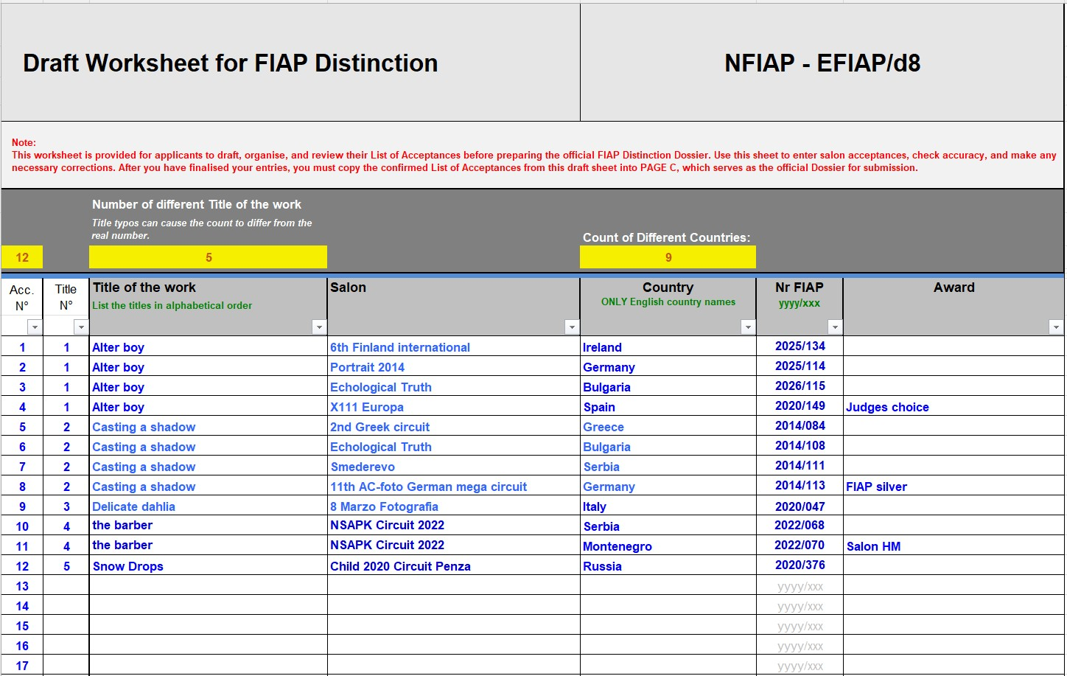

to paste results from this work sheet into your application form you must use “paste values” not the standard paste or shortcut paste keys. Paste values just pastes the data and doesn’t interfere with functions and formatting of the form. If you use the normal paste it overwrites the functions and the automatic counts at the top won’t work.

The Title Number
This relates to each new title. Titles with the same name will have the same number. An image must retain the same title throughout all salons no matter if it is in B&W or colour.

The “Title” Column
The title must be that which appears in the catalogue. The title should be the same for ALL acceptances for that image. The practice of using the same title for different images, differentiated by a number is to be strongly discouraged. This is because some exhibitions do not include such numbers in their catalogues; consequently, such acceptances may not be verifiable.
Many exhibitions place limits on the length of titles. This can vary from 25 to 35 characters including spaces. With ‘on‐line’ entry systems that refuse a title if it does not comply, you need to bear this in mind as well. Unlike our “Natural History” naming requirements the international salon’s “Nature” section does not require Latin sub‐titles, apart from the fact that they are hard to fit on the 35‐character limit, they are rarely if ever read out to the selectors and even more rarely are they included in catalogues, they just need to reflect simple concepts like 'Gannett feeding chick'.

The “Salon” Column
It is totally unnecessary to include full details of longwinded salon names. All that information is not needed. In the case of a stand‐alone Exhibition, such as say “The 32nd Northern Counties International Salon of Photography 2019” they don’t need all that. All they need you to put in the Salon column is Northern Counties. In the case of a Circuit, they do need more information, because they also need to know which salon of the Circuit is involved, because each salon has its own number despite being part of a circuit. Another example: the “Linz” Exhibition in the “Trierenberg Super Circuit should be shown as Trierenberg circuit–Linz. A second example may be the “Carlisle” Exhibition of the “Great British Small Prints Circuit”. This can be shown simply as GB S/Prints circuit – Carlisle
The “Country” Column
In dealing with this please remember that England, Scotland and Wales are separate countries and should be shown as such.
When you start to type the country’s name, the form will offer you some options, choose which one you are trying to type in.

The “FIAP No.” Column
Remember that your recording of the FIAP number must be accurate. FIAP will check your acceptance record against their central Database of Salon Results. If it doesn’t show on their database then it will not be accepted.
the difference between a Salon and a Circuit.
A salon is a single event, which is likely to have different sections (eg: Open, Nature, Photo‐Travel etc) into which you can enter images and these will be judged just the once.
A Circuit will comprise of more than one Salon, each having identical sections, so that the photographs you submit will be passed from one salon to another and can then gain acceptances and awards in each salon. Sometimes the different salons are registered to different countries as well. It is possible to have multiple acceptances for an image in a circuit, and there might be more than one country involved. Each salon within the circuit will have its distinct salon number

A final note.
Recommendations for FIAP recognitions are processed through the FIAP Liaison Officer for each country and can only be applied for all together once a year.
It has been my practice to start asking for your draft spreadsheet at the end of June so I can have a quick look to check you are on the right track.
At this time, if you haven’t already done so, you will be asked to go online and register for your 'personal ID number and 'photographers' card'. See ‘Details on how to apply for a FIAP Life card’ in the ‘FIAP application forms’ tab
Later in the year we will get the other forms sorted out. The final dossiers will be sent all together to FIAP on 1st September

Obviously, you have to achieve the relevant criteria BEFORE you request a FIAP Distinction. NO title, acceptance or award will count towards any application for a distinction until the salon involved has submitted their Salon Report, which contains all the results, to FIAP. Salons are required to submit these files within a specified length of time, but many are late by quite a few months. It is therefore pointless relying on Report Cards, Email or Website notifications.
You can check whether FIAP has received the Salon Report by visiting http://www.myfiap.net/patronages
In the “Listings by Months” you will find that there is a box for each event that will indicate ‘Yes’ or ‘No’ in this respect. Unless ‘Yes’ is in this column DO NOT INCLUDE that salon’s results in your application.

